Journey to the Edge of our Planet
By: Jagriti Luitel

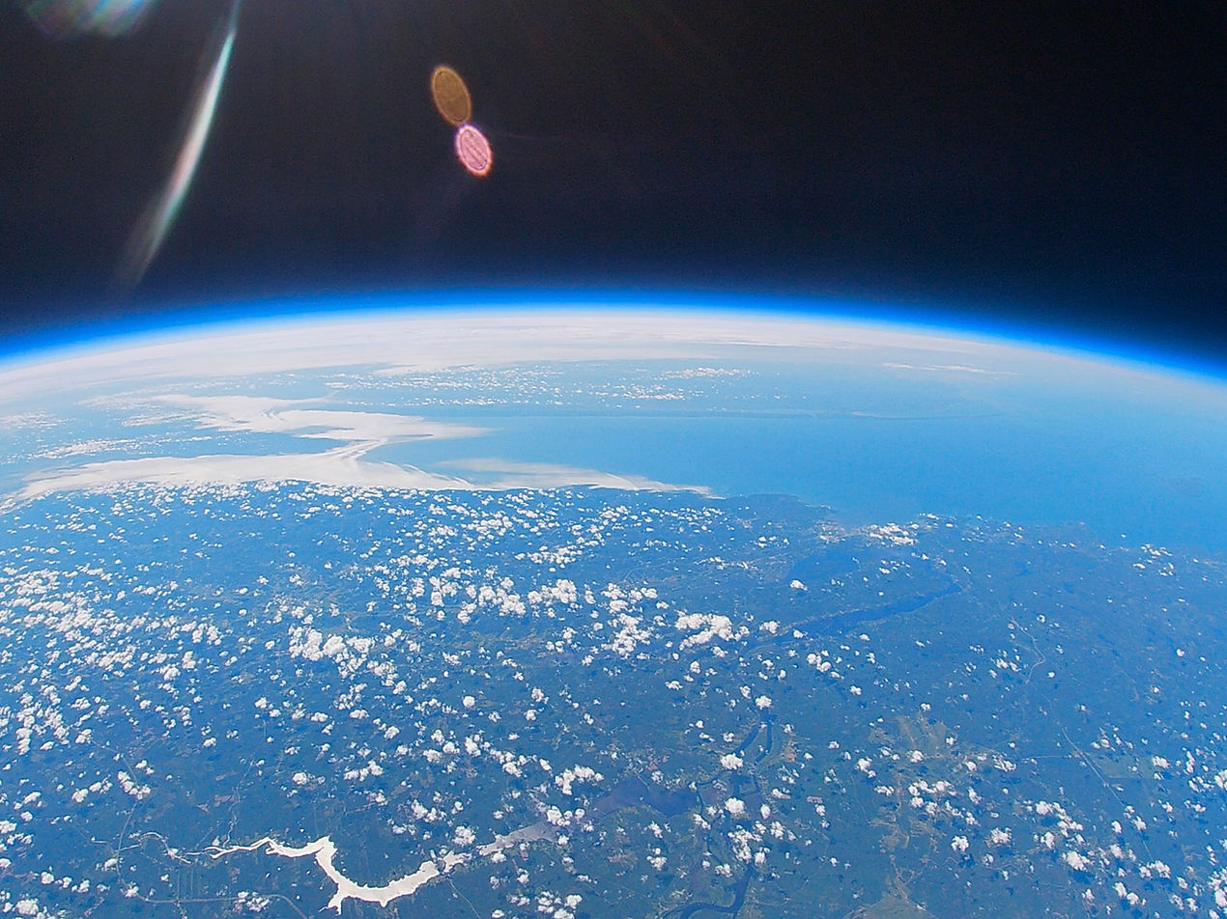
Figure 1: Image captured by GoPro Camera at 103,000 ft
The reflection of the Earth's curvature was clearly visible in my eyes. “fascinated”, “immersed”, and “enthralled” accurately describe what I felt at that moment. Then, a small yet significant thought made its presence clear. It whispered, "maybe you can do this yourself?"
I sit here after over two years from this exact moment. One that ignited an entrepreneurial spirit in me and now has translated into several aspects of my life. Where now, instead of waiting for someone else to build something first and become a part of it, I start my own. For example, in my recent webinar to Student for Exploration and Development of Space (SEDS-Nepal) on taking Nepal to space, I pitched how leveraging politics to start national-level space projects is essential for developing countries. The confidence for this idea was developed in me after successfully founding, leading, and executing a High-Altitude Balloon (HAB) project and launching it 103,000 feet into the stratosphere. This attracted several Canadian media outlets such as CBC, CTV, and UNB News to accomplish tangible aerospace public engagement in the province of New Brunswick, Canada. Personally, a project whose ripple effects still echo within me to this day.
It all started on a Sunday afternoon as I sat on my couch during the summer after graduating high school. I stumbled on a video of Go Pros being sent into space where the magnificent curvature of the earth was shown instigating the exact moment described in the beginning of this story. This was during the COVID-19 pandemic when I was seeking meaningful investments of my time and energy through aerospace projects which could also excite me to my core. The pandemic was months old at the time, social events were at a standstill and a long, torpid summer yawned ahead of me. I knew that I would have to find other ways of hands-on learning since all the lab portions of the engineering classes were done online. Philosophically, I also felt a void of meaninglessness in the mundane, so I knew I had to change my trajectory.
The video had such a profound effect on me that I felt like I didn’t have a choice but to do it. I then spent the next 15 days determined to bring the project to fruition but soon realized its ginormous scope and how it was clearly outside my capabilities.
I decided to quit.
Deciding to quit was the easy way out. I would not have to discover if I am capable or not if I never tried. This reminds me of the quote by the American writer Marianne Williamson, "Our deepest fear is not that we are inadequate, our deepest fear is that we are powerful beyond measure. It is our light, not our darkness that most frightens us."
Then, a few months passed where it all changed. I stumbled across a video by a famous science communicator, Emily Calandrelli on her balloon project when she decided to announce her pregnancy using a HAB. The striking female representation in the video was enough to rekindle my fire and I decided not to be afraid of the light this time. I restarted the project and spent some time making a list of reasons why I was unsuccessful in my first attempt. The project feels too large? Get a team. Too expensive to personally execute? Seek out external funding. Scared of legal implications? Delegate. There. That is how seemingly impossible feats are undertaken. Taking one step at a time. Solving one issue at a time.
Thus, in November 2020, StratoFredericton was born. Over the next eight months, the team made up of two other engineering students from my university John Estafanos and Ryan Whitney met consistently on weekends for several hours to discuss engineering project management, teamwork, social media strategies, technical details, legalities, and funding applications.
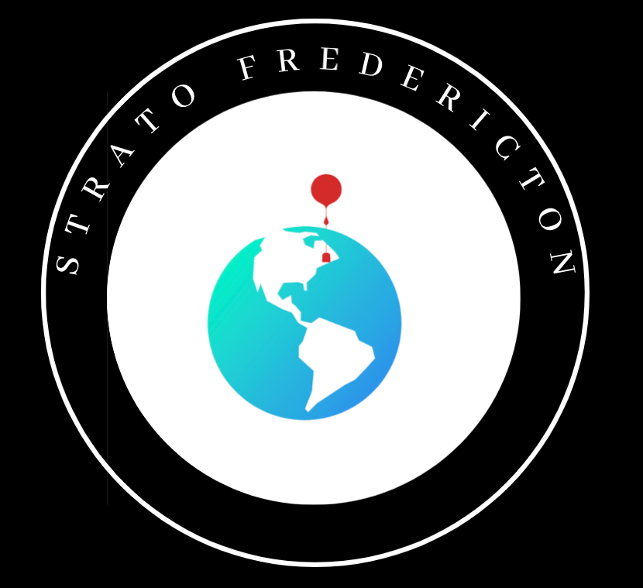
Figure 2: The Official Logo of StratoFredericton designed by Jagriti Luitel
Determined to add symbolic meaning to the project, I asked a local environmental organization if I could send a poster of their logo to Space to support a message that today's youth under the Sustainable Development Goals take climate action seriously. The organization agreed and I went on to hand-paint it on a poster to add a creative touch to the project.
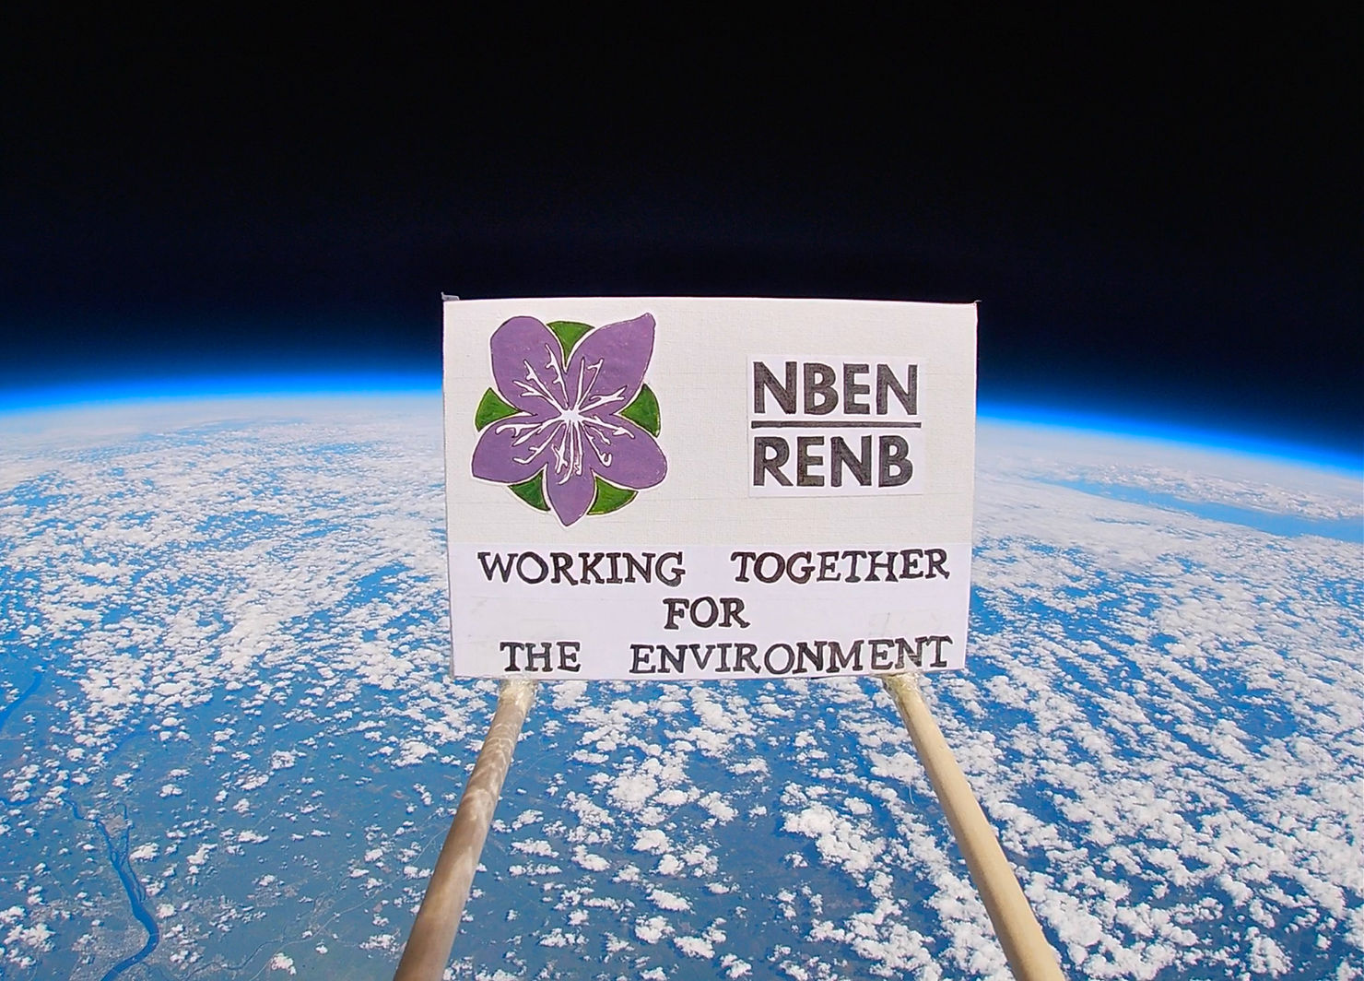
Figure 3: The image of a hand-painted environmental poster in front of the curvature of Earth leveraging the overview effect
Another important lesson was about embodying the importance of feminine principles of leadership such as empathy, creativity, and intuition in a traditionally masculine field. It also felt vital to give other girls more opportunities to see women taking initiative and leading as their authentic selves.
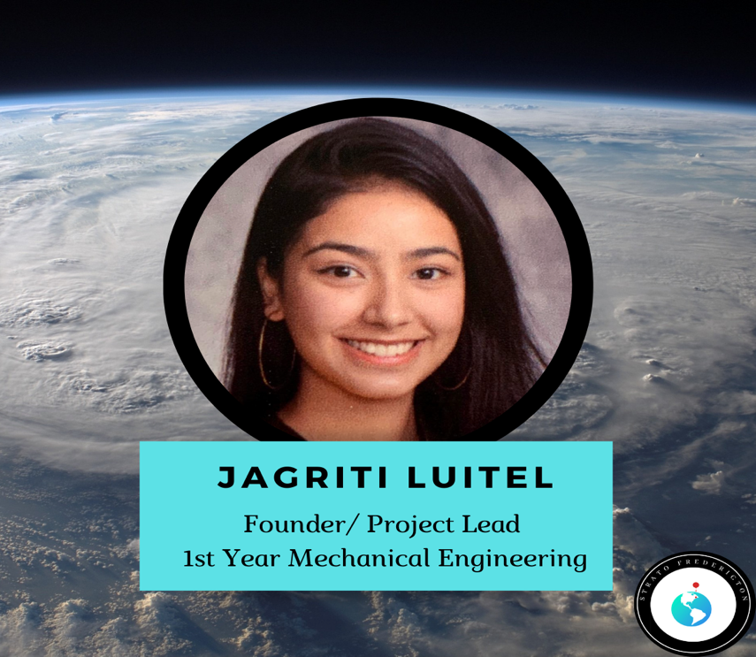
Figure 4: The graphics designed by Jagriti to promote the project on different social media platforms
Finally, the launch day arrived but the first attempt failed due to a minor calculation error. This gave us a good taste of how rigor and resilience are important factors for success in aerospace. The second launch succeeded, and the payload was almost miraculously recovered beside a lake. After recovery, I stepped away from my teammates and turned one of the Go Pros on.
The reflection of the earth's curvature was clearly visible in my eyes. “fascinated”, “immersed”, and “enthralled” accurately describe what I felt at that moment. Then a small yet significant thought made its presence clear. This time it whispered, "You did it".
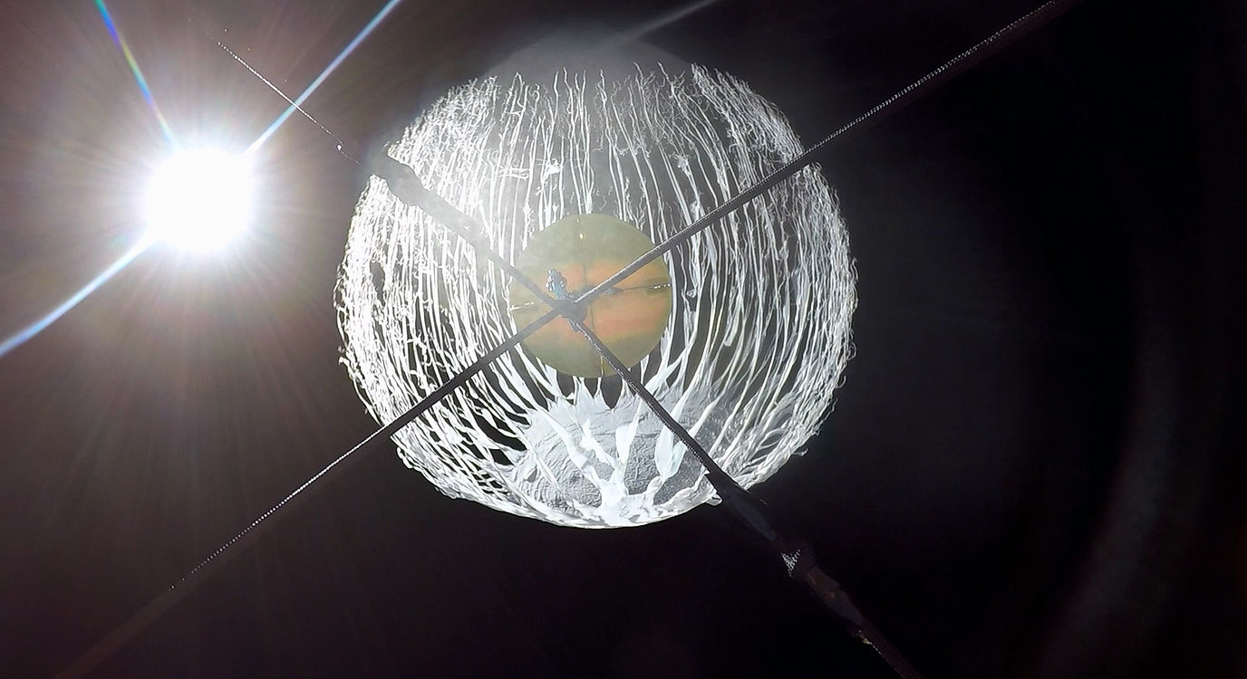
Figure 5: HAB bursting at the peak of the trajectory with the Sun in the background

