Space for Disaster Management
By: Jagriti Luitel
बुबा, यो समाधान सही छ? (Dad, is this solution right?)
I curiously look up for an answer deviating from a prolonged stare into my grade 8 math assignment on a cozy Saturday morning. Taking my notebook in his hands, he begins checking my work. Before he says something, I feel a sudden wave of dizziness and start hearing a rumbling sound. Our eyes suddenly meet, and we both realise the ground is violently shaking. It was the 7.8 Mw magnitude earthquake that hit Nepal in 2015. The bookshelves and the cupboards started caving in. A broken flower vase even cut my sister’s hand causing it to bleed unstoppably. Although we made it out from the chaos safely, the terror of the aftermath was nothing like I had ever experienced.
The entire nation was brought to a halt. Aspirations, dreams, and longings becoming secondary, survival triumphed as the priority in everyone’s lives. Many weeks after the initial hit, we were still sleeping on the ground of an open space near my house praying that the aftershocks wouldn’t cause our home to collapse. Since the open sky above me became the only thing that I associated with hope, I spent several nights stargazing. One night specifically, I vividly remember curiously looking up when a thought whispered in me, “you are so small”. That was the kind of macroscopic vantage point I needed to comprehend my education being compromised for months and seeing how obtaining even the basic human needs are in fact a privilege.
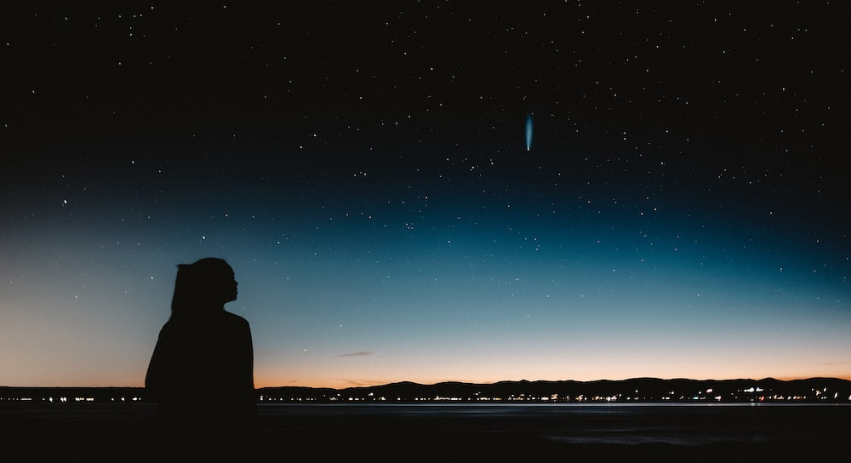
Figure 1: Girl staring at the night sky. Image credit: unplash.com

Space exploration is often portrayed as an elitist endeavor. As if only the most powerful countries and the richest amongst us get to push the frontier of human exploration. Human exploration. Something that is innate in all of us and yet for most people in developing countries, it is just another unattainable privilege. While the field of aerospace is primarily driven by capital
investments like developed countries are third world countries like Nepal are mostly labour driven. Adding several other challenges onto that, the entire industry through a global lens is exceedingly unequitable.
The earthquake was just an example. Through my first-hand experience, I learned that people in countries like Nepal are consumed by dealing with fundamental problems such as poverty, hunger, and more disasters like landslides and flooding. On one hand, the benefits of space technologies have been proven to be enormous for the upliftment of any economy. While on the other, it is nowhere close to being utilized where it is needed the most. Bridging this huge gap is what the aerospace industry is missing. For example, food security is increasingly at risk due to climate change caused mostly by the powerful countries and corporations. For an average farmer in Nepal, the untimely droughts remain unexplained. In this case, satellite data can be used to generate predictive models, so the farmers are locally empowered. Extrapolating this framework onto other fields such as resource management, urban planning, disaster management, security, and communication can and should be the next steps.
Youth like myself, who have seen the vulnerabilities of one region and the possibilities of another, can act as the connectors to bridge this gap. For me, being a person of colour, an immigrant in Canada of 3 years and a woman has posed several challenges while navigating this field. However, I also believe that it has positioned me in a highly favorable place to make impactful change for others. Seeking to scale this impact, I have given workshops to Nepal, specifically dedicated to educating girls about space and the use of space technologies in developing countries for disaster management.
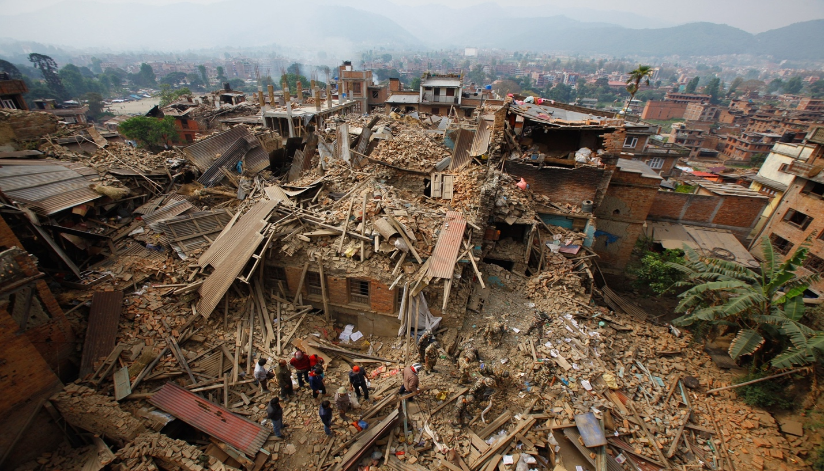
Figure 2: Picture taken after the 7.8 magnitude earthquake in Nepal. Image credit: Niranjan Shrestha
My interest in space had been omnipresent until the earthquake, but that confrontation was the tipping point in turning it into a deep lifelong fascination. I do not know if my solution to the math problem was ever right, but I do know that a combination of humility and the urgency for impactful change is what drives me. And even though bridging the gap is an essential first step, I imagine the possibility of a grander world. A world where anyone, regardless of race, gender, birthplace, age, and socio-economic background can curiously look up at the stars and say to themselves, “this is mine to explore”.

